EE5630 DSP f2020 HW# 1 (ch.2) Due 15:30, 10/8/2020

1. (10%)

The signals *x*[*n*] and *y*[*n*] shown below are the input and corresponding output for an LTI system.

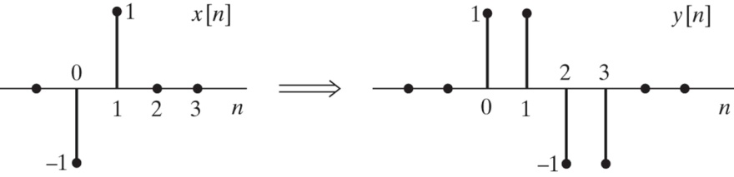

1. Find the response of the system to the input sequence *x*2[*n*] in the figure shown below.

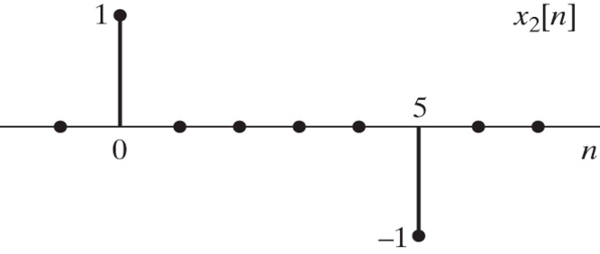

1. Find the impulse response of the system.

2. (10%)

For each of the 5 systems (A~E) shown below, pick the strongest valid conclusion that you can make about each system from the following list of statements:

(i) The system must be LTI and is uniquely specified by the information given.

(ii) The system must be LTI, but cannot be uniquely determined from the information given.

(iii) The system could be LTI, and if it is, the information given uniquely specifies the system.

(iv) The system could be LTI, but cannot be uniquely determined from the information given.

(v) The system could not possibly be LTI.





For all choices of *x*[*n*]*, y*[*n*]*,* and the constant **

3. (10%)

The system *L* in Figure shown below is known to be ***linear***. Shown are three output signals *y*l[*n*],

*y*2[*n*], and *y*3[*n*] in response to the input signals *x*l[*n*], *x*2[*n*], and *x*3[*n*], respectively.

(a) Determine whether the system *L* could be ***time invariant***.

(b) If the input *x*[*n*]to the system *L* is **[*n*]*,* what is the system response *y*[*n*]*?*



4. (10%)

A DT LTI system has frequency response given by

1. Find the impulse response *h*[*n*] of the system.
2. Determine the difference equation that is satisfied by the input *x*[*n*] and output *y*[*n*] of the system.
3. If the input to this system is *x*[*n*] = 4 + 2cos(**0*n*) for -∞<*n*<∞, for what value of **0 will the output be of the form *y*[*n*] = *A* = constant for -∞<*n*<∞? What is the constant *A*?

5. (10%)

Two sequences *x*1[*n*] and *x*2[*n*] are shown below. Both sequences are zero for all *n* outside the region shown. The Fourier transform of these sequences are *X*1(*ej*) and *X*2(*ej*), which, in general, can be expected to be complex and can be written in the form

*X*1(*ej*) = *A*1(**)*exp*(**1(**)),

*X*2(*ej*) = *A*2(**)*exp*(**2(**)),

where *A*1(**), **1(**), *A*2(**), **2(**) are all real functions chosen so that both *A*1(**) and *A*2(**) are nonnegative at ** = 0, but otherwise can take on both positive and negative values. Determine appropriate choices for **1(**) and **2(**), and sketch these two phase functions in the range 0 <**<2**.

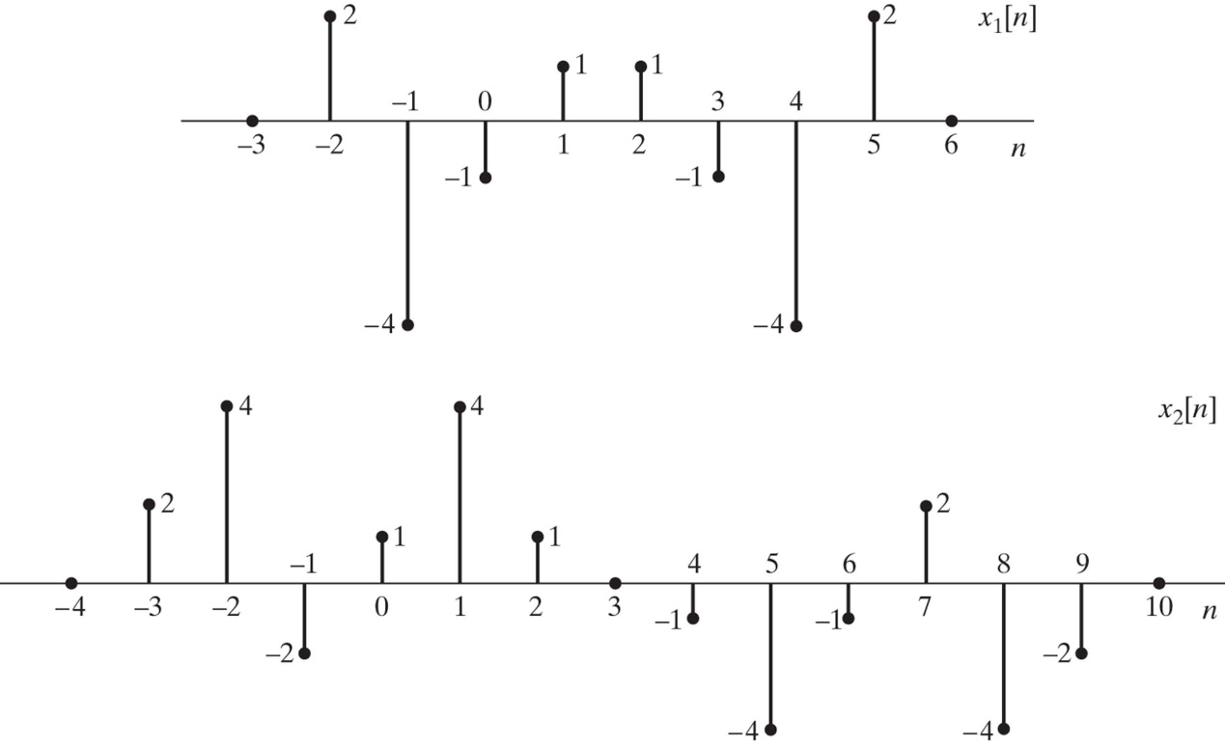

6. (10%)

Consider the cascade of discrete-time systems in the following figure. The time-reversal systems are defined by the equations *f*[*n*] = *e*[-*n*] and *y*[*n*] = *g*[-*n*]. Assume throughout the problem that *x*[*n*] and *h*1[*n*] are real sequences.

1. Express *E*(*ej*), *F*(*ej*), *G*(*ej*), and *Y*(*ej*) in terms of *E*(*ej*) and *H*1(*ej*).
2. The result from part (a) should convince you that the overall system is LTI. Find the frequency response *H*(*ej*) of the overall system.
3. Determine an expression for the impulse response *h*[*n*] of the overall system in terms of *h*1[*n*].

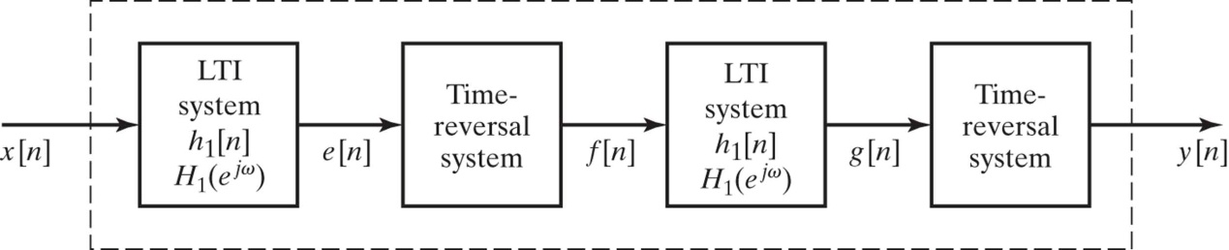

7. (10%)

Let *x*[*n*] and *y*[*n*] denote complex sequences and *X*(*ej*), *Y*(*ej*) their respective Fourier transforms.

1. Determine the sequence whose Fourier transform is *X*(*ej*)*Y*\*(*ej*).
2. Find the Fourier transform of .
3. Express the series in terms of *X*(*ej*) and *Y*(*ej*).
4. Determine the numerical value of .

8. (10%)

Consider the system with input *x*[*n*] and output *y*[*n*] illustrated below, where *h*[*n*] represents the impulse response of an LTI and *u*[*n*] is the unit-step sequence.

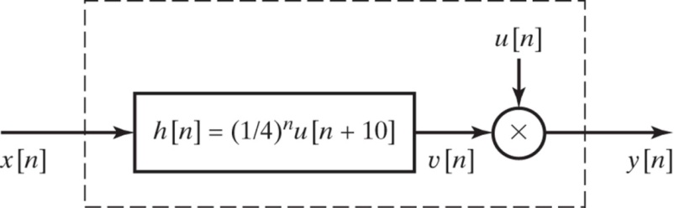

1. Is the overall system LTI?
2. Is the overall system causal?
3. Is the overall system stable in BIBO sense?

9. (10%)

Consider the system shown below, where the subsystems Sl and S2 are LTI.



(a) Is the overall system enclosed by the dashed box, with input *x*[*n*] and output *y*[*n*]equal to the product of *y*1[*n*]and *y*2[*n*]*,* guaranteed to be an LTI system? If so, explain your reasoning. If not, provide a counterexample.

(b) Suppose Sl and S2 have frequency responses *H*1(*ej* )and *H*2(*ej* )that are known to be zero over certain regions. Let



Suppose also that the input *x*[*n*]is known to be bandlimited to 0.3*,* i.e.,



Over what region of -* * ≦ ** < ** is *Y*(*ej* )*,* the DTFT of *y*[*n*]*,* guaranteed to be zero?

10. (10%)

Consider a discrete-time LTI system with frequency response *H*(*ej* )and corresponding impulse response *h*[*n*]*.*

**(a)** We are first given the following three clues about the system:

(i) The system is causal.

(ii) *H*(*ej* )= *H\**(*e-j* )*.*

(iii) The DTFT of the sequence *h*[*n* +1] is real.

Using these three clues, show that the system has an impulse response of finite duration.

**(b)** In addition to the preceding three clues, we are now given two more clues:

(iv)



(v) *H*(*ej* ) = 0.

Is there enough information to identify the system uniquely? If so, determine the impulse response *h*[*n*]*.* If not, specify as much as you can about the sequence *h*[*n*]*.*